**Observation 39-enforcing complex data integrity values**

Create table:

CREATE TABLE employees2 (

employee_id NUMBER PRIMARY KEY,

job_id VARCHAR2(10)

);

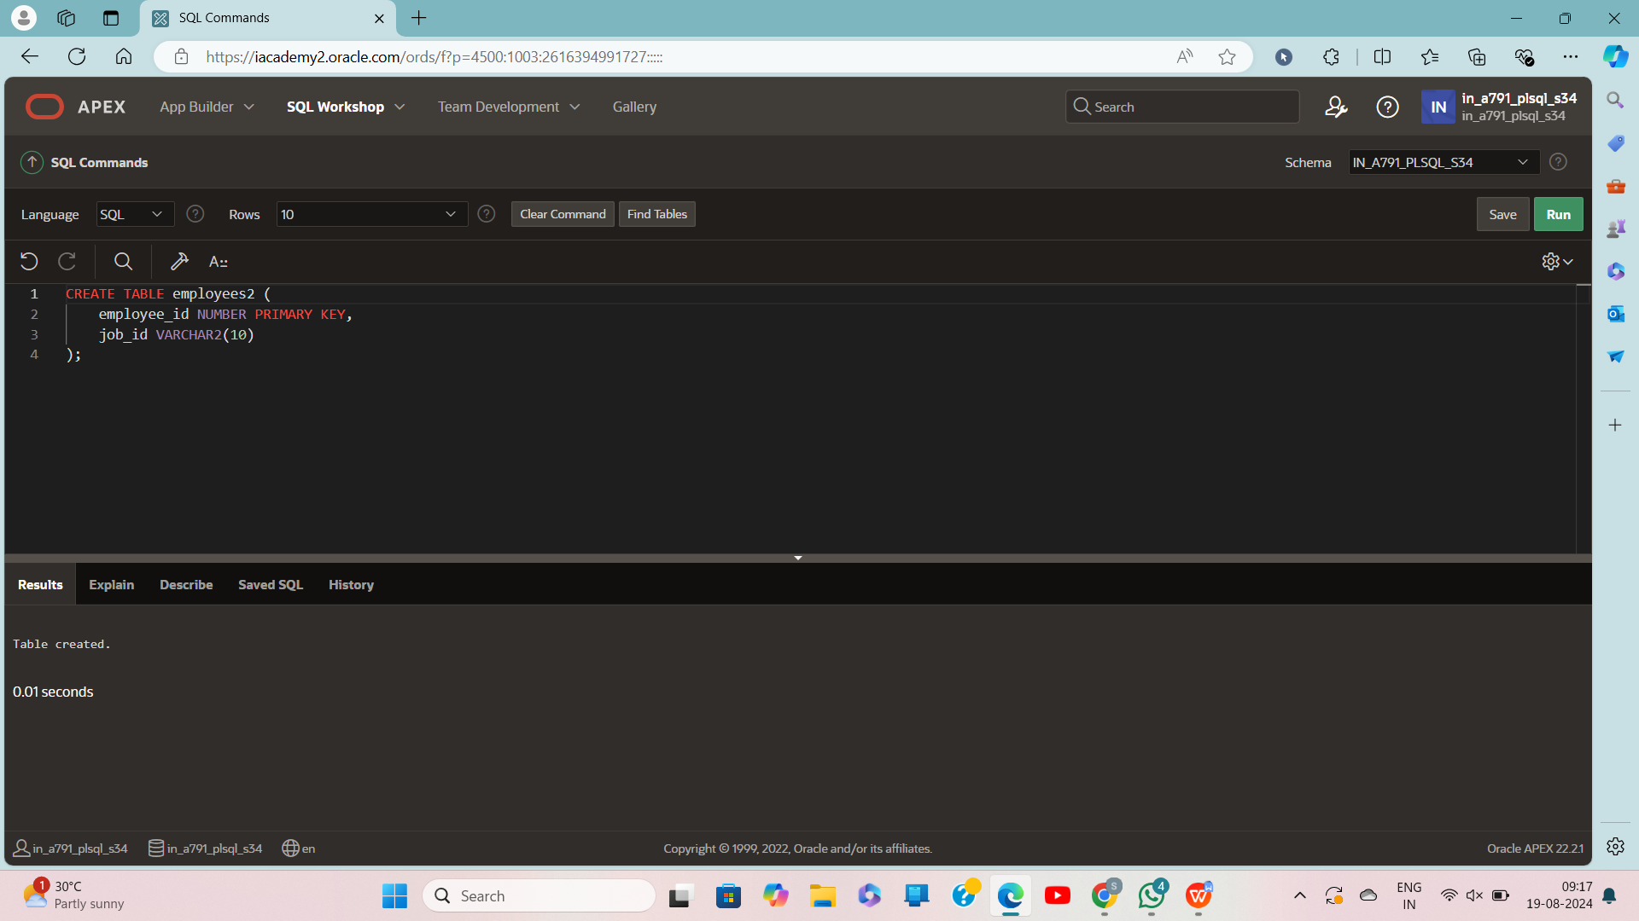

Create job:

CREATE TABLE job_data (

employee_id NUMBER,

job_id VARCHAR2(10),

start_date DATE,

end_date DATE,

FOREIGN KEY (employee_id) REFERENCES employees2(employee_id)

);

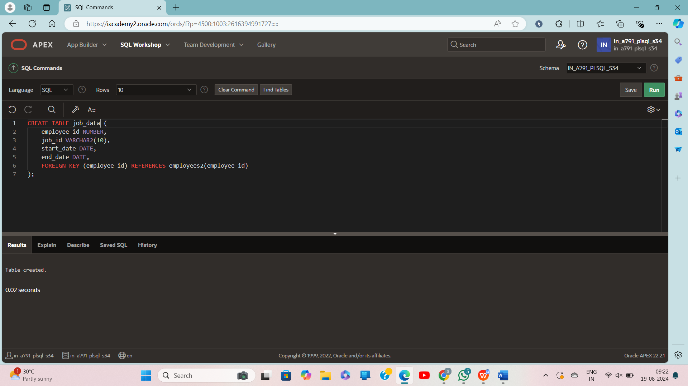

**Insert values:**

INSERT INTO employees2 (employee_id, job_id) VALUES (101, 'DEV');

INSERT INTO employees2 (employee_id, job_id) VALUES (102, 'MANAGER');

INSERT INTO employees2 (employee_id, job_id) VALUES (103, 'ANALYST');

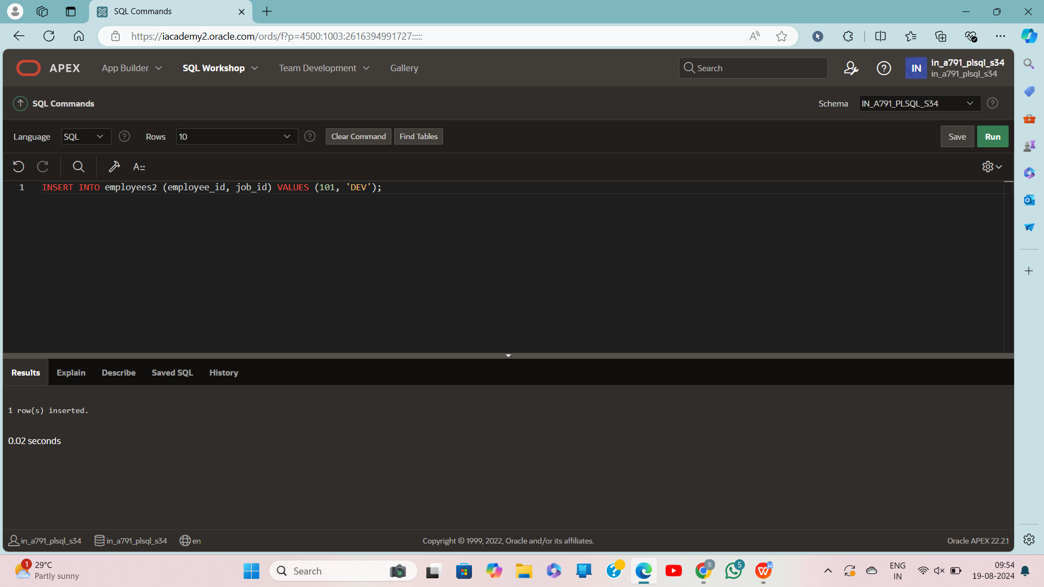

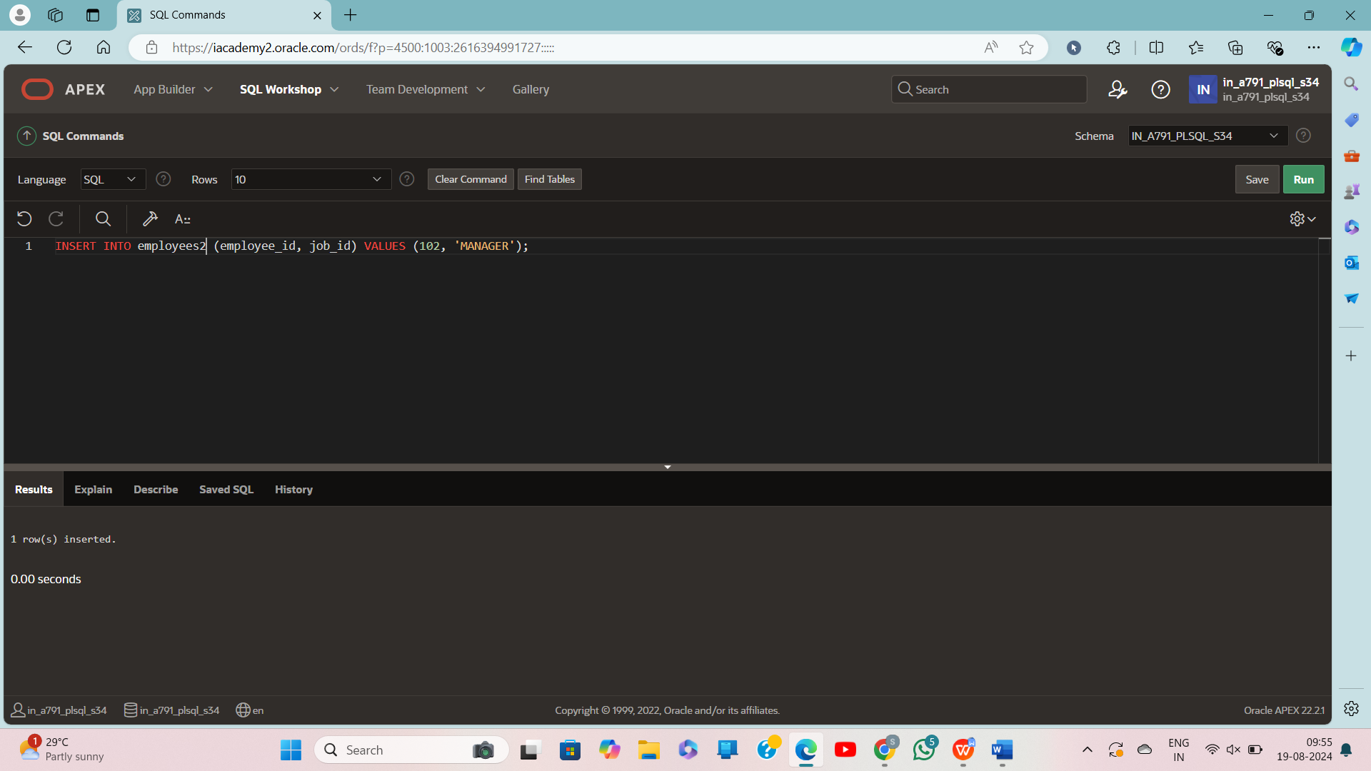

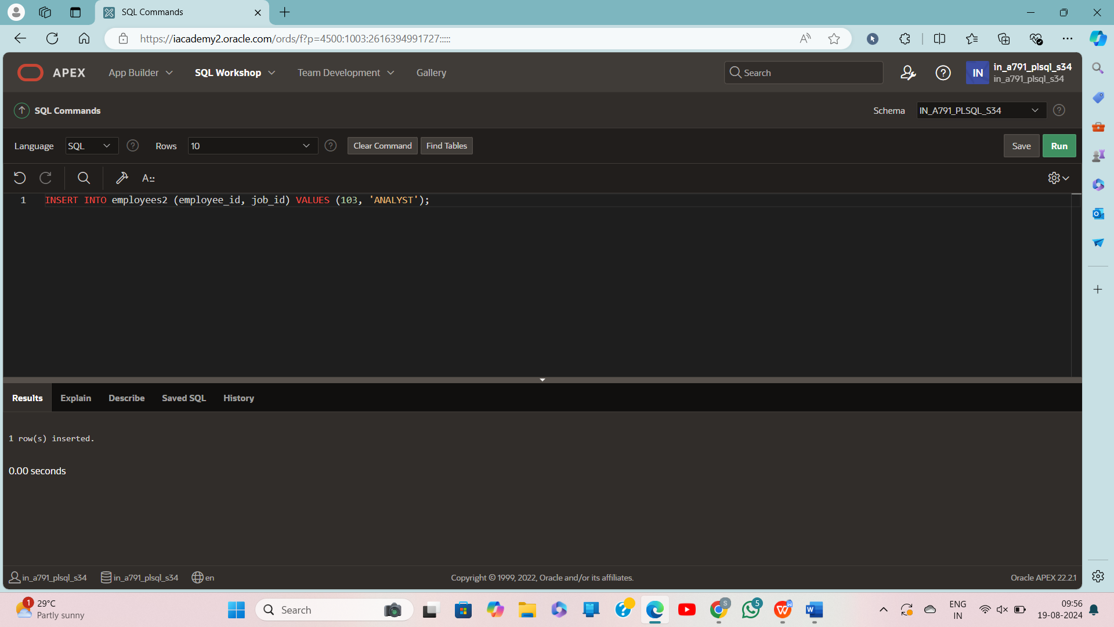

Insert in job:

INSERT INTO job_data (employee_id, job_id, start_date, end_date) VALUES (101, 'ANALYST', TO_DATE('2023-01-01', 'YYYY-MM-DD'), TO_DATE('2023-06-30', 'YYYY-MM-DD'));

INSERT INTO job_data (employee_id, job_id, start_date, end_date) VALUES (102, 'DEV', TO_DATE('2022-01-01', 'YYYY-MM-DD'), TO_DATE('2022-12-31', 'YYYY-MM-DD'));

INSERT INTO job_data (employee_id, job_id, start_date, end_date) VALUES (103, 'DEV', TO_DATE('2022-05-01', 'YYYY-MM-DD'), TO_DATE('2023-01-31', 'YYYY-MM-DD'));

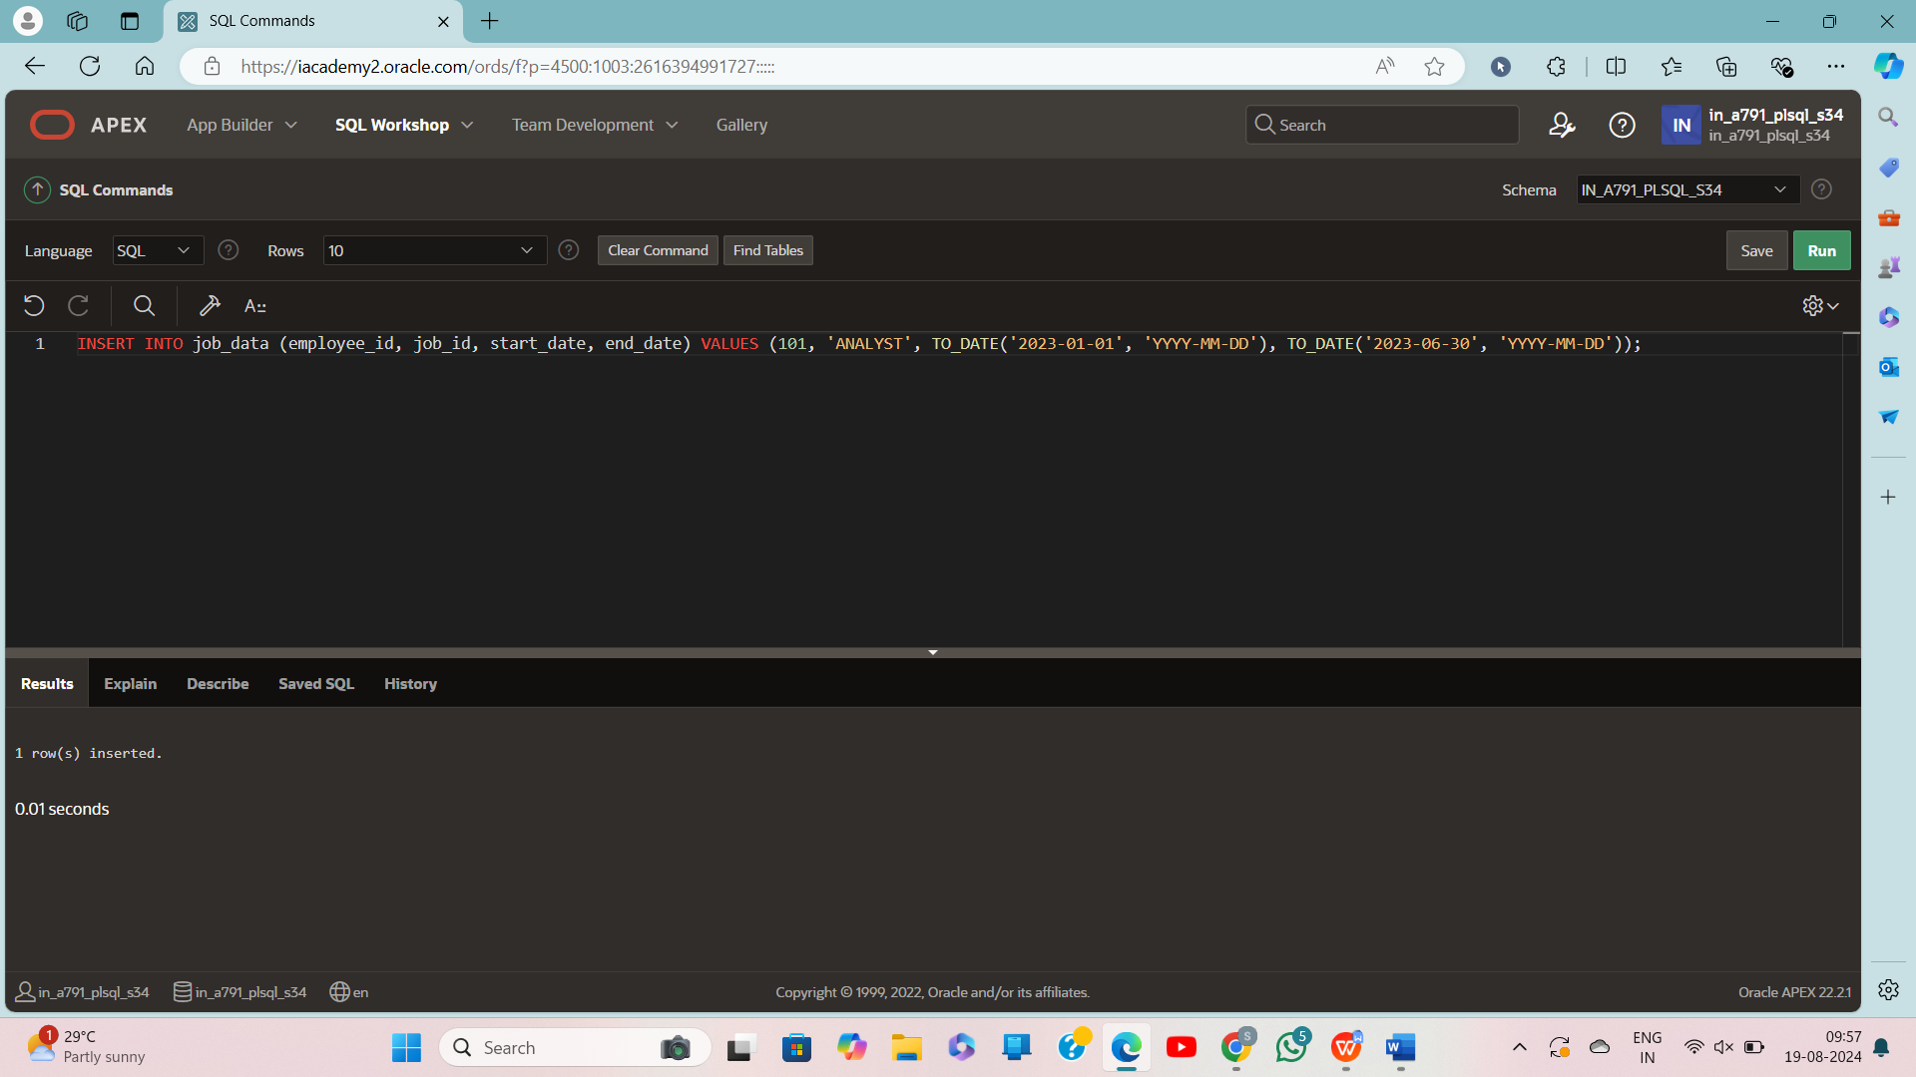

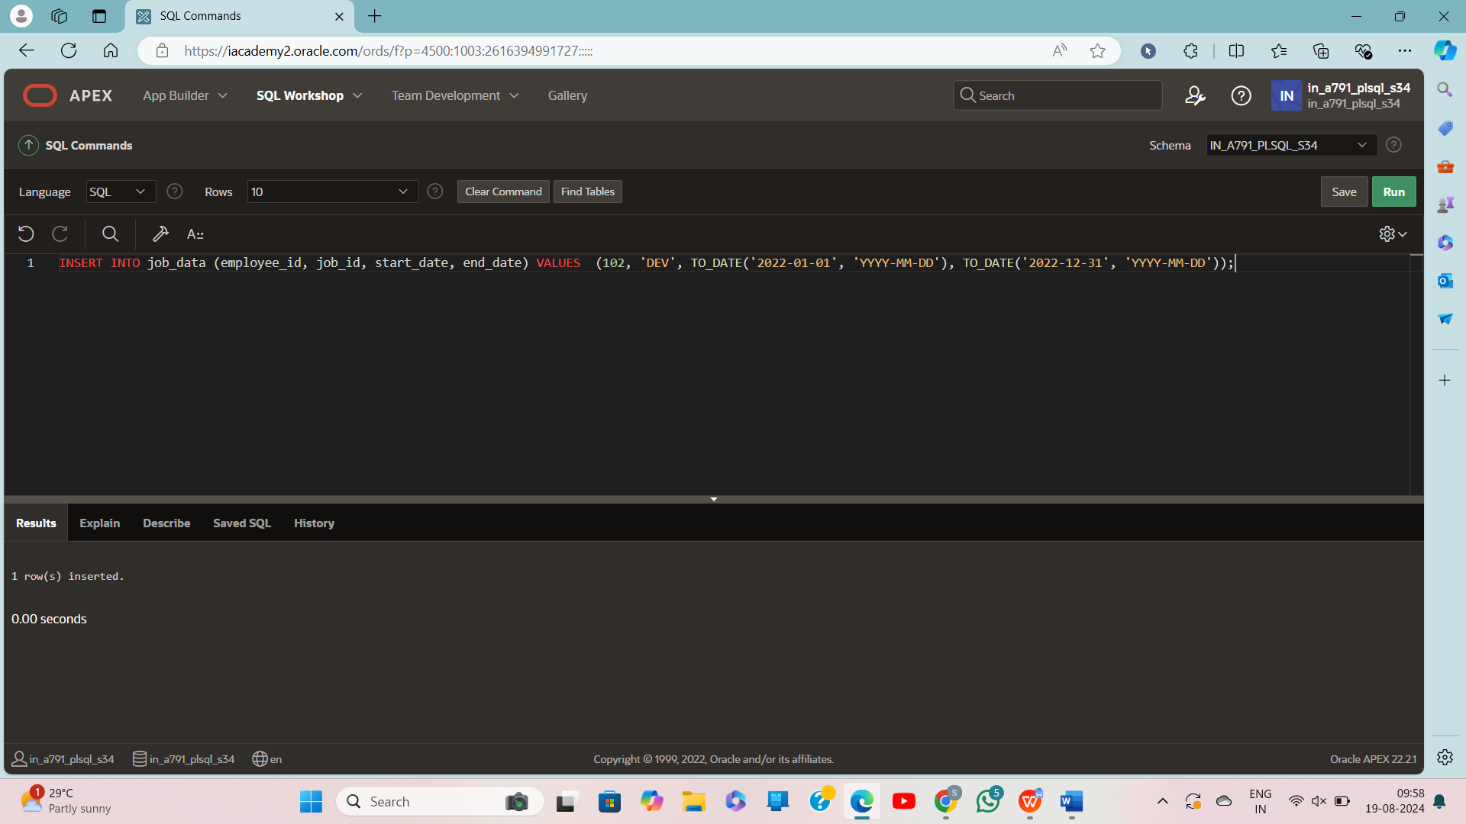

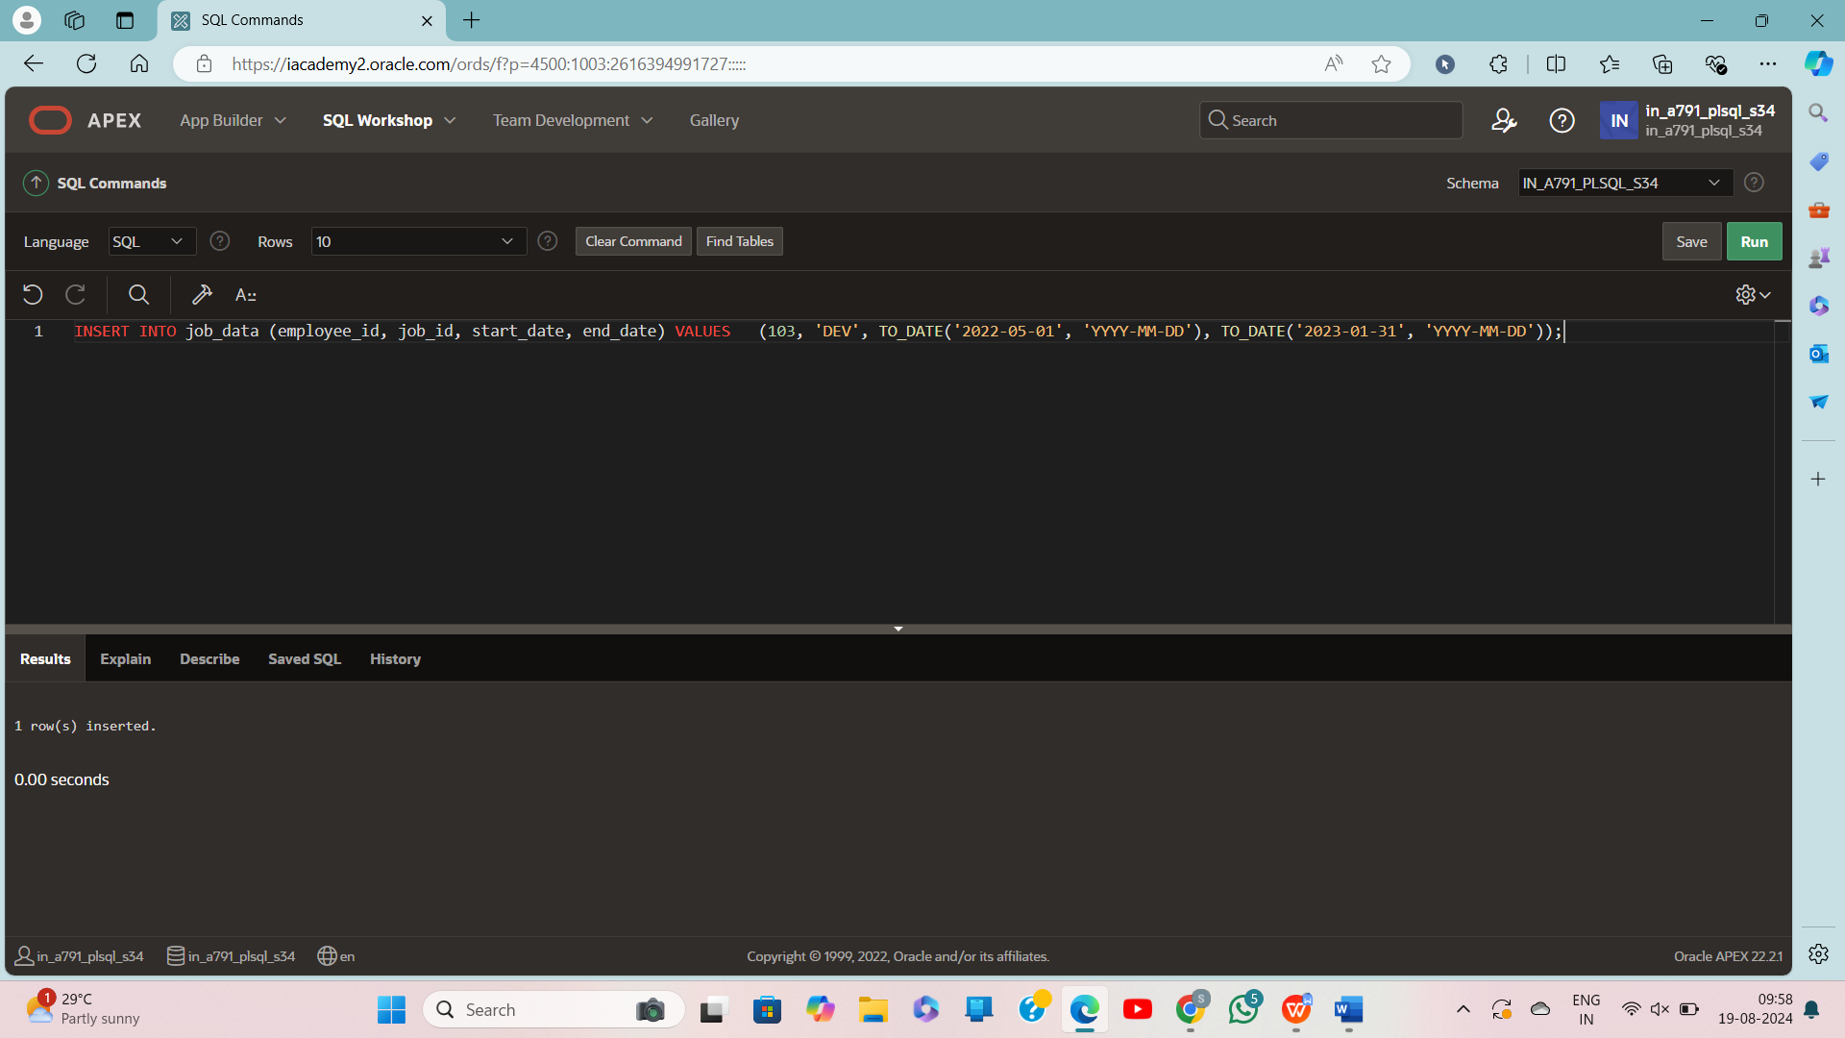

**Create trigger:**

CREATE OR REPLACE TRIGGER check_sal_trigg

BEFORE UPDATE OF job_id ON employees

FOR EACH ROW

DECLARE

v_job_count INTEGER;

BEGIN

-- Check if the new job_id already exists in the job_history for the same employee

SELECT COUNT(*) INTO v_job_count

FROM job_history

WHERE employee_id = :OLD.employee_id

AND job_id = :NEW.job_id;

-- If the job has already been done, raise an error

IF v_job_count > 0 THEN

RAISE_APPLICATION_ERROR(-20201, 'This employee has already done this job');

END IF;

END;

/

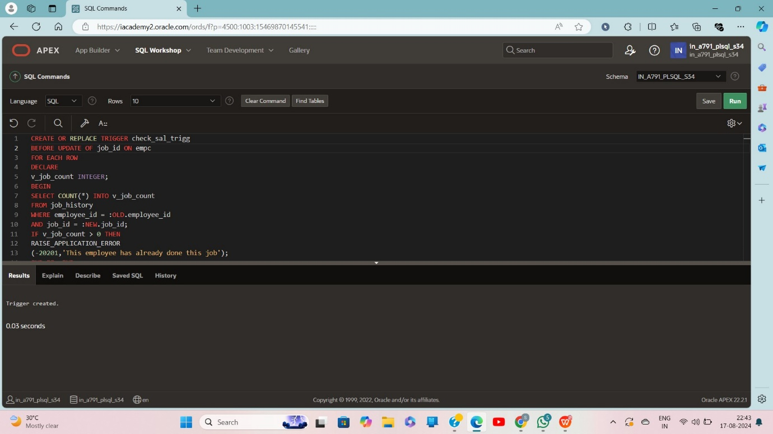

select*from job_data

